Heart Disease Prediction – MLOps Pipeline

Overview
This project implements an end-to-end MLOps pipeline for heart disease prediction using the KDD Cup 1999–style dataset (binary classification: normal vs attack). The pipeline covers data preprocessing, EDA, model training, experiment tracking with MLflow, containerization with Docker, deployment on Kubernetes (Minikube), logging, and simple monitoring via Prometheus-style metrics.
- Setup and Installation
1.1 Prerequisites
- Python 3.x
- pip
- Docker
- Minikube
- kubectl
- Git

1.2 Setup & Installation — Action/Command Table

Setup Step | Command(s) to Run
Clone the repository | git clone https://github.com/subhasajayan/mlops-heart-disease cd mlops-heart-disease
Create and activate virtual environment | python -m venv venv venv\Scripts\activate
Install dependencies | pip install -r requirements.txt
Run experiments locally | python src/train.py
Build Docker image | docker build -t heart-api .
Start Minikube | minikube start
Load Docker image into Minikube | minikube image load heart-api
Apply Kubernetes deployment | kubectl apply -f k8s/deployment.yaml
Apply Kubernetes service | kubectl apply -f k8s/service.yaml
Get service URL | minikube service heart-api-service --url

2. EDA & Modelling Choices
2.1 Dataset Preparation
The project uses the KDD-style heart disease dataset, originally provided in .dat format. To ensure reproducibility and ease of use, the repository includes:
- A Python script to download the .dat file directly from the source.
  - data\script\download_data.py
- A Python conversion script that transforms the .dat file into a structured .csv file.
  - src\preprocess.py
- Automated preprocessing steps inside the training pipeline to load the .csv file for EDA and modelling.
- On top in data folder contains both .dat and csv file ready to use
  - data\processed\heart_clean.csv
  - data\raw\heart.dat
This ensures that anyone running the project can reproduce the dataset preparation without manual intervention.

2.2 Exploratory Data Analysis (EDA)
Key findings:
- Dataset contains 270 rows and 14 columns.
- No missing values.
- Balanced target classes (150 vs 120).
- Histograms show reasonable distributions.
- Correlation heatmap highlights strong predictors (thalach, oldpeak, cp, slope).

2.3 Feature Engineering
Using ColumnTransformer:
- Numeric features scaled using StandardScaler.
- Categorical features encoded using OneHotEncoder.
- Unified preprocessing pipeline ensures consistent transformations.

2.4 Train/Test Split
- 80/20 split.
- Stratified to preserve class balance.
- Shapes: Train (216), Test (54).

2.5 Model Development
Two models were trained:
- Logistic Regression (max_iter=1000)
- Random Forest (n_estimators=200, random_state=42)

2.6 Model Evaluation
Logistic Regression
- Accuracy: 0.8703
- ROC-AUC: 0.9139
Random Forest
- Accuracy: 0.8333
- ROC-AUC: 0.8875
Conclusion: Logistic Regression performed better.

2.7 Cross-Validation
- Logistic Regression Mean ROC-AUC: 0.9128
- Random Forest Mean ROC-AUC: 0.9113

2.8 Final Model Selection
Final model: Logistic Regression Saved as best_model.pkl and preprocessor.pkl.

3. Experiment Tracking Summary (MLflow)

3.1 MLflow Integration
MLflow was used to track:
- Hyperparameters
- Metrics (accuracy, precision, recall, F1, ROC-AUC)
- Artifacts (ROC curve, confusion matrix, saved models)
- Run history for comparison
Tracking URI: sqlite:///mlflow.db Experiment name: heart_disease_classification

3.2 Logged Artifacts
- ROC Curve
- Confusion Matrix
- Saved model (MLflow format)
- Preprocessing pipeline

3.3 MLflow UI
Launch using:
Step | Command
Start MLflow UI | mlflow ui --port 5001

4. Architecture Diagram (Text-Based)

4.1 System Architecture Overview

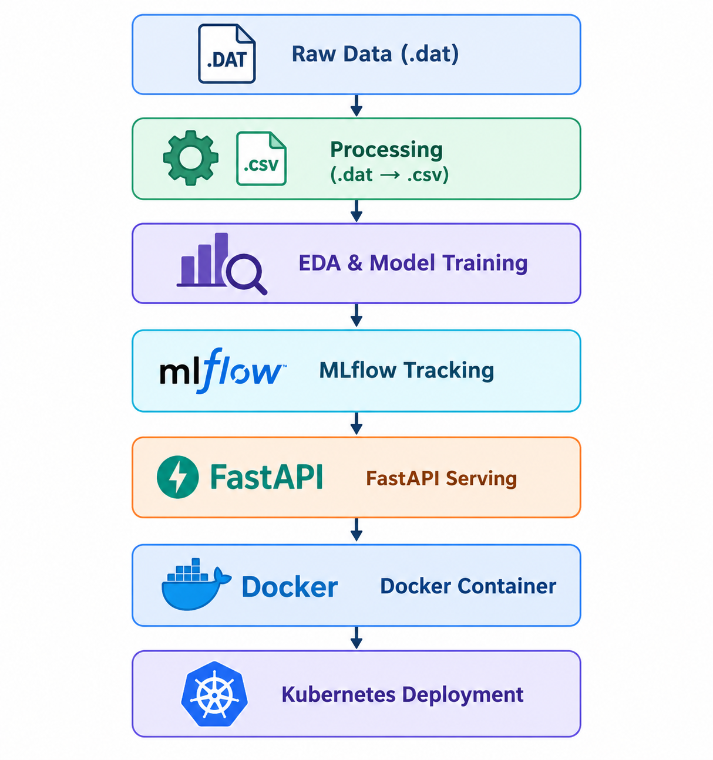

4.2 Explanation
- Data flows from raw .dat → cleaned .csv.
- EDA + training produce the final model.
- MLflow logs experiments.
- FastAPI serves predictions.
- Docker containerizes the API.
- Kubernetes deploys the service.
- Minikube exposes the endpoint.

5. CI/CD & Deployment Workflow

5.1 CI/CD Pipeline
A GitHub Actions workflow includes:
- Linting
- Unit tests
- Model training
- Artifact upload
- Deployment triggers

5.2 Deployment Workflow
Step | Command
Build Docker image | docker build -t heart-api .
Load image into Minikube | minikube image load heart-api
Apply deployment | kubectl apply -f k8s/deployment.yaml
Apply service | kubectl apply -f k8s/service.yaml
Get service URL | minikube service heart-api-service --url

6. Screenshot Titles

6.1 MLflow UI – Experiment List

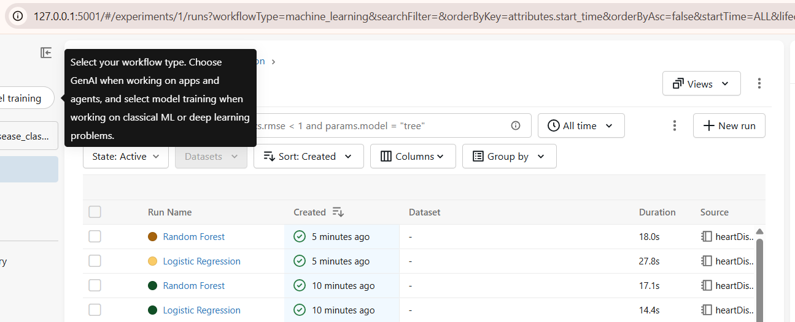

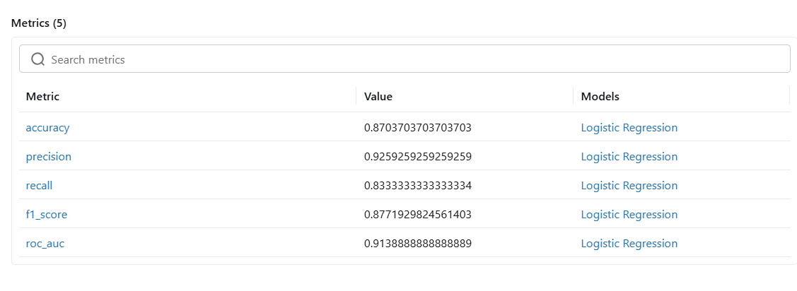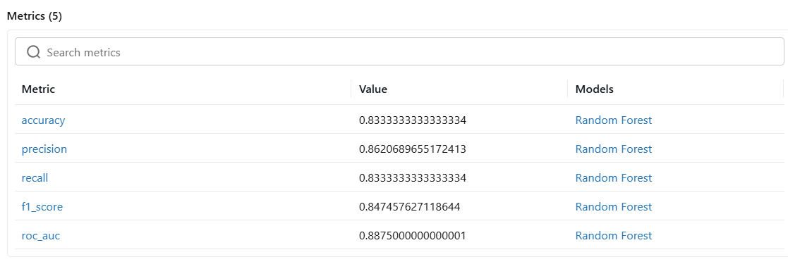

6.2 MLflow – ROC Curve Artifact

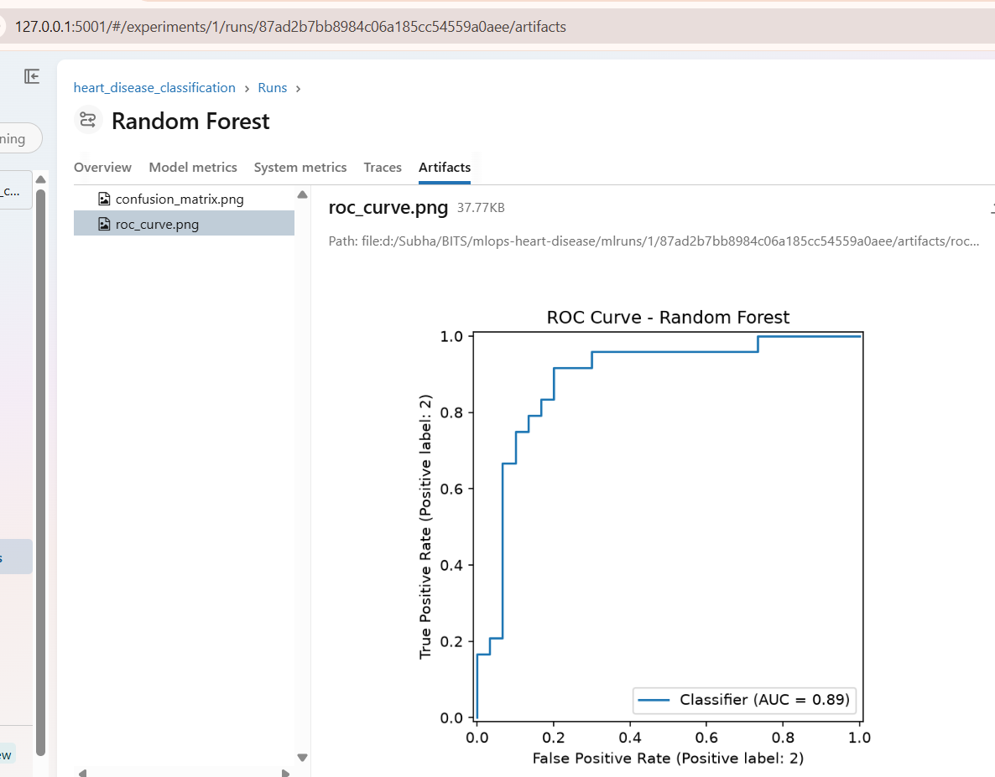

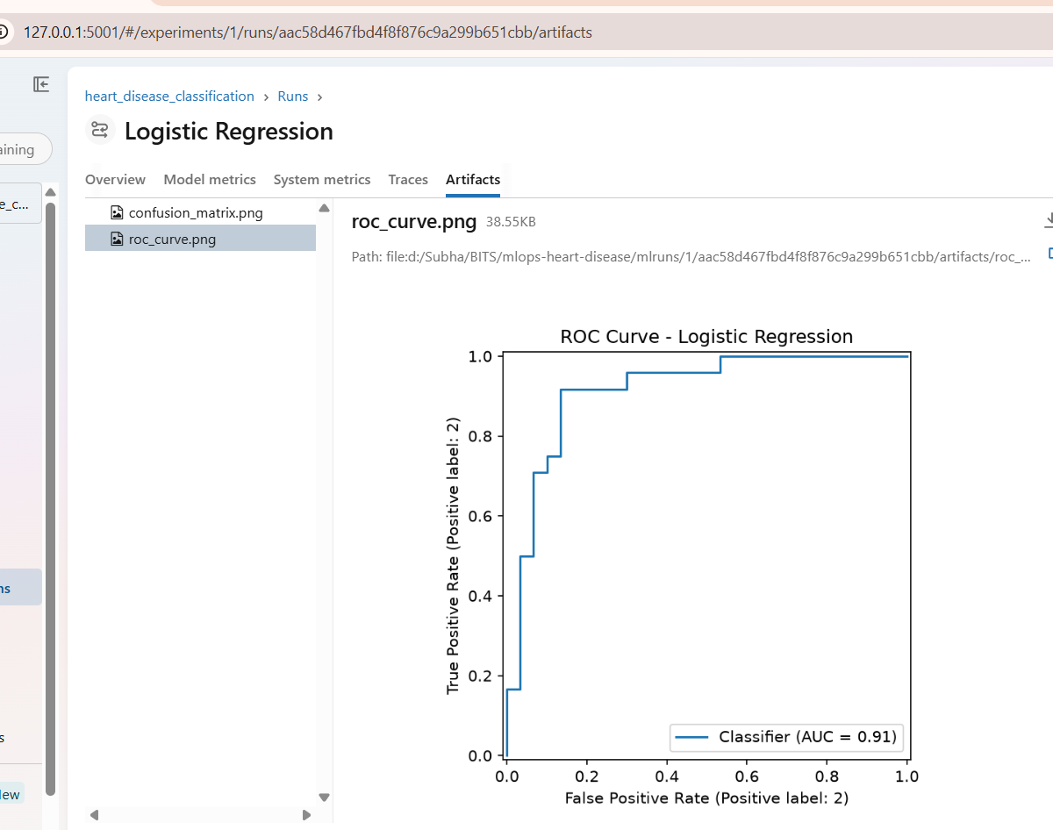

6.3 MLflow – Confusion Matrix Artifact

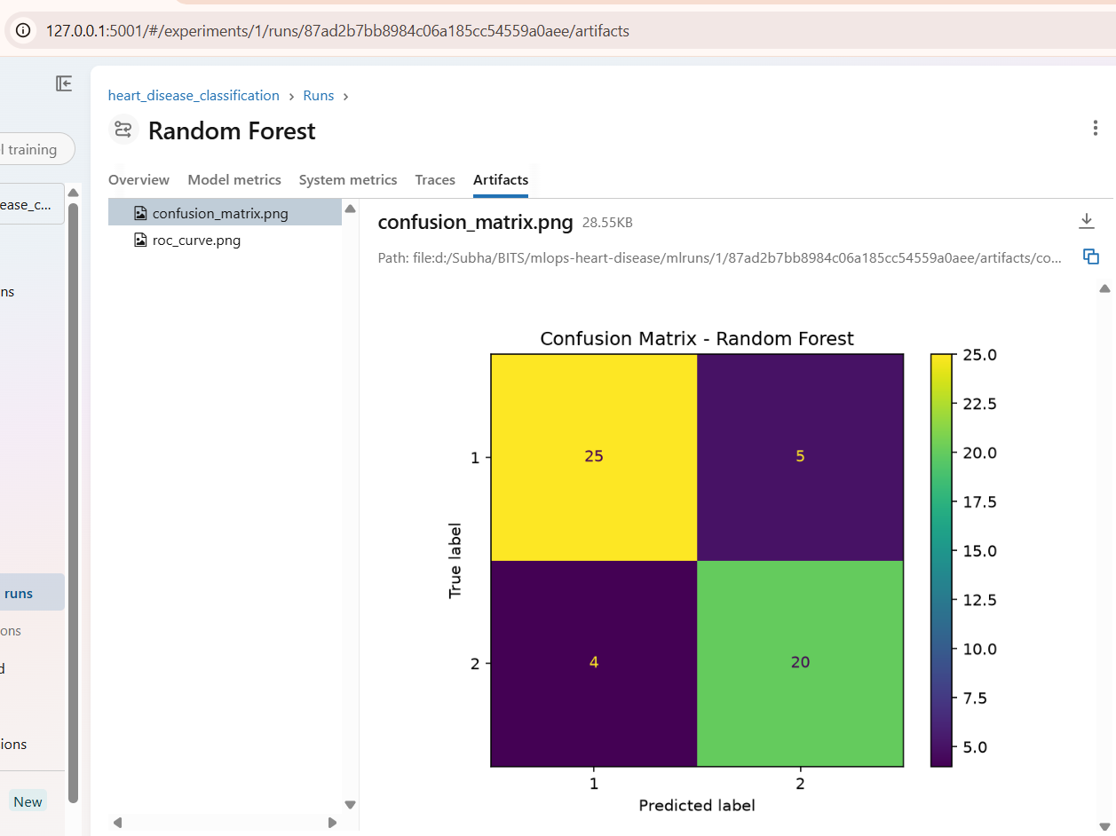

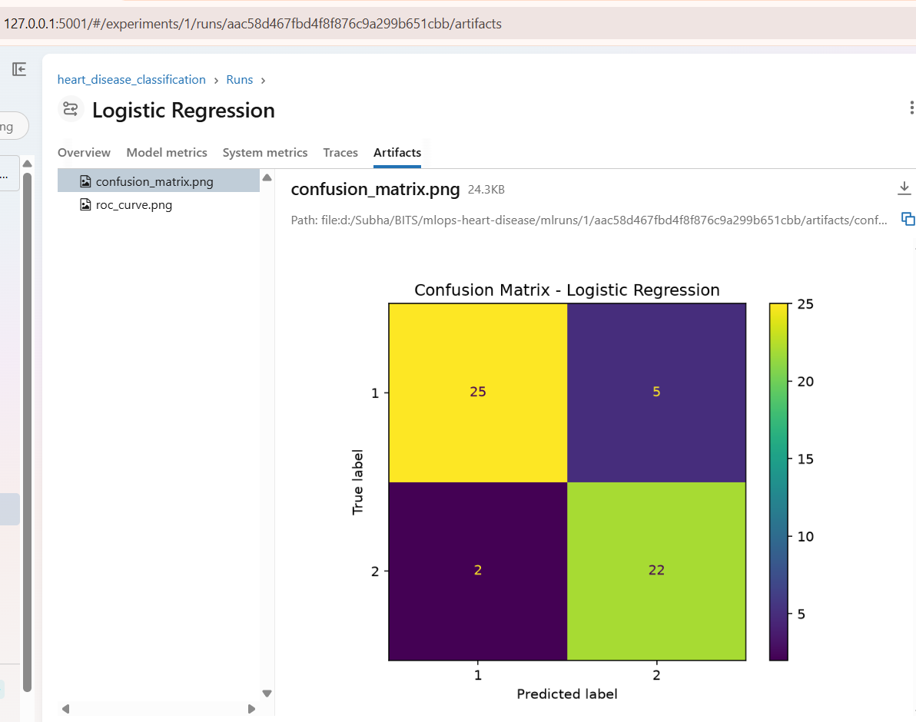

6.4 Docker Build Success

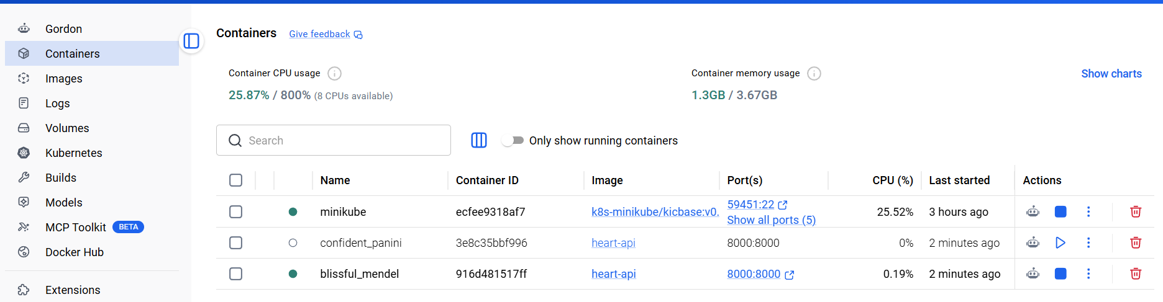

6.5 Kubernetes Deployment (kubectl get pods)

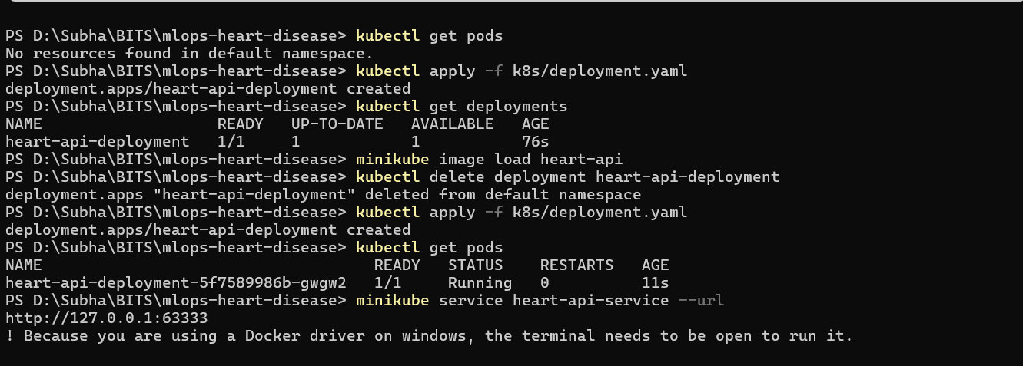

6.6 Kubernetes Service (kubectl get svc)

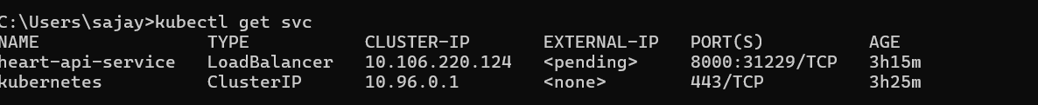

6.7 FastAPI Swagger UI (/docs)

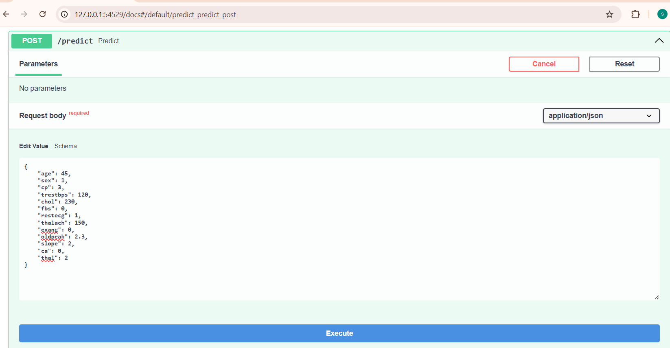

6.8 Prediction Response (/predict)

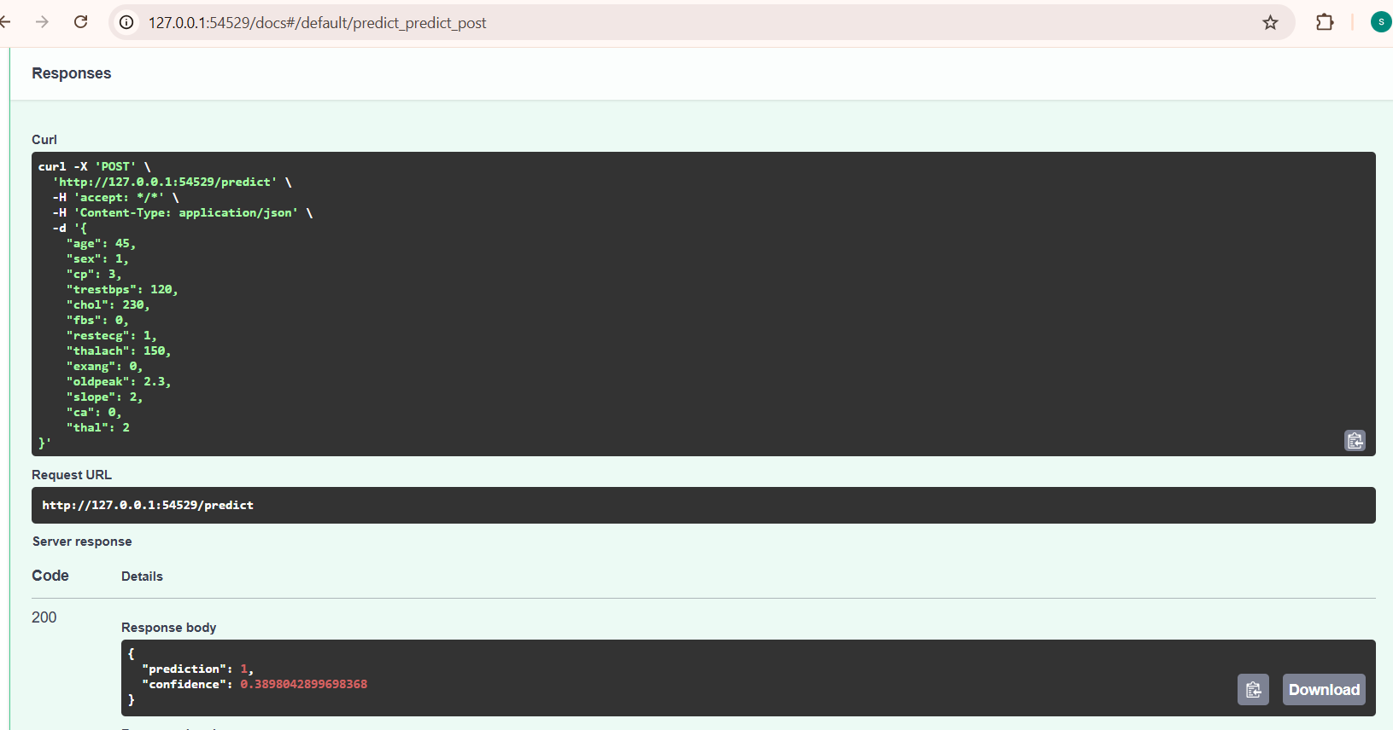

6.8 Logs (/predict)

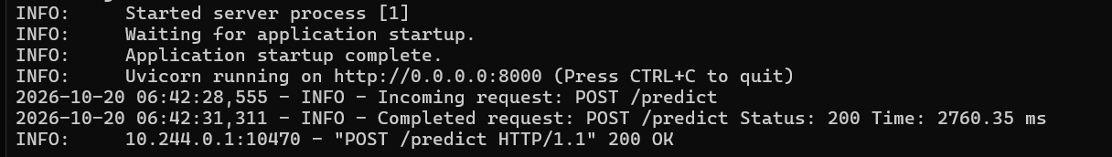

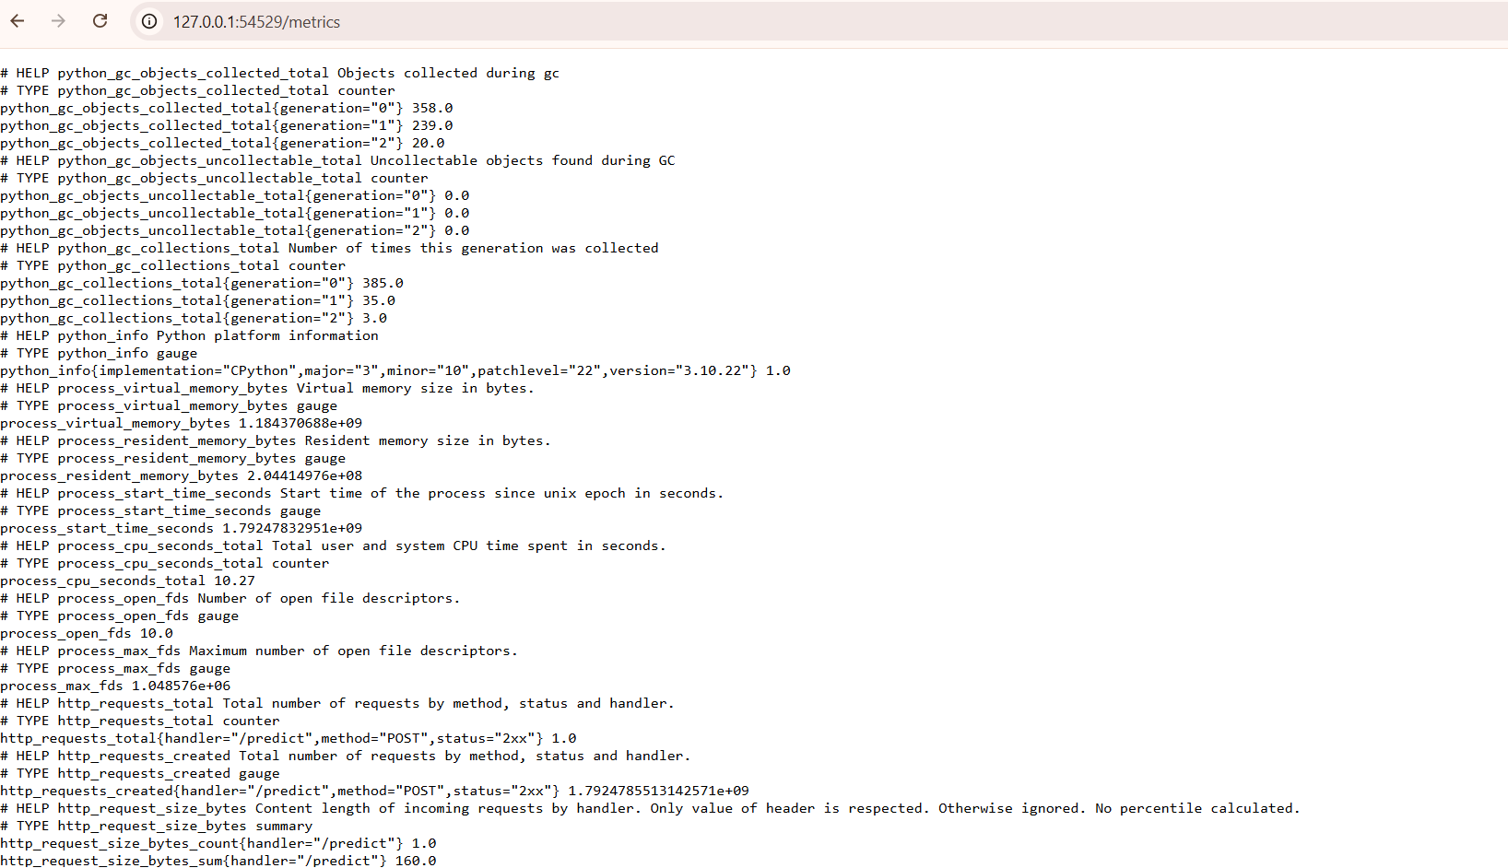

6.8 Git workflow action

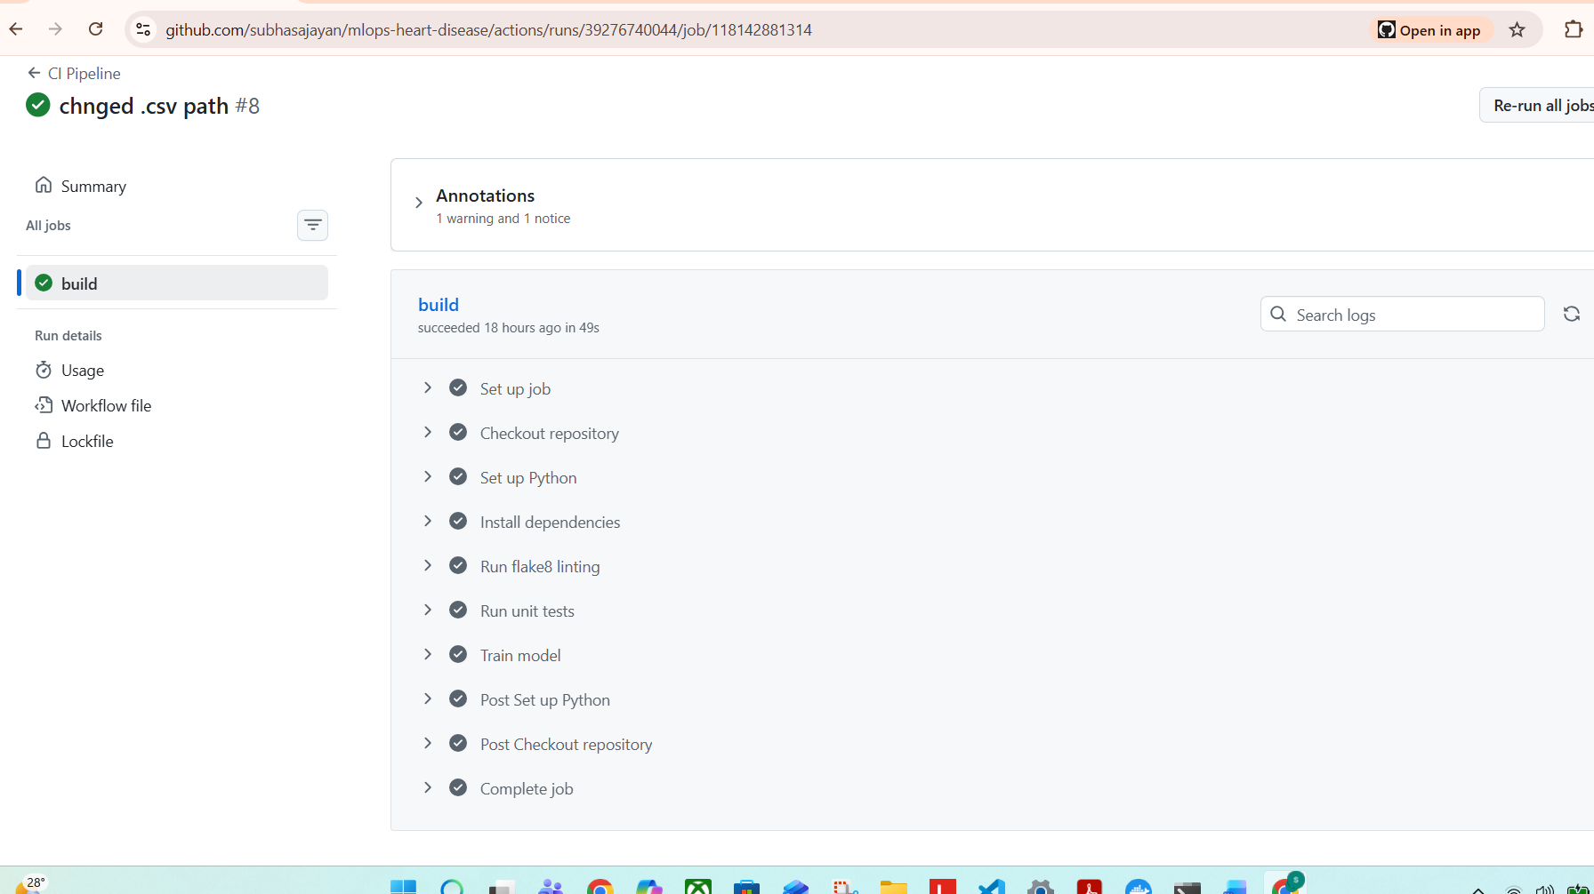

7. Repository Link
GitHub Repository: https://github.com/subhasajayan/mlops-heart-disease

8. Conclusion
This project demonstrates a complete MLOps workflow for heart disease prediction, including data acquisition, EDA, feature engineering, model development, experiment tracking, containerization, and Kubernetes deployment. The pipeline is fully reproducible, modular, and ready for extension into production environments.

